**Team 4**

**January 30, 2015**

**Project 1: Fastener’s**

**2002 SV650S Suzuki**

**Mechanical Component: Cylinder Head Bolt**

**Brandon Tolbert**

**2.1 Design and Statics**

The loading condition being evaluated on the mechanical component is when the cylinder pressure is 4000 kPa caused by the upward movement of the piston. In this case two forces act in the axial direction of the engine block bolt, the force due to the tightening of the bolt, i.e. the preload (P1), and the force do to the piston (P2). The resulting Free Body Diagram (FBD) with bolt dimensions is shown below:

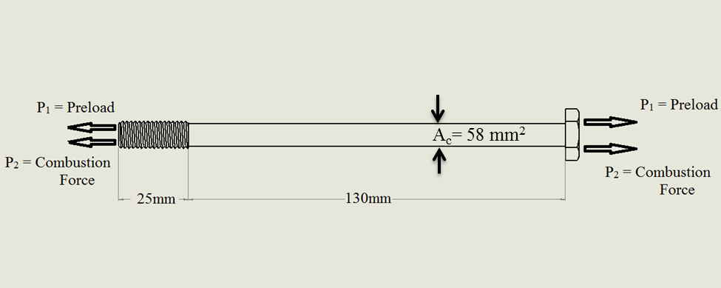

Figure 1 shows the Free Body Diagram and the resulting stresses acting on the bolt

When the bike is not running, only the preload force exists. Using the static force equilibrium equations the resulting forces can be determined:

(1)

The preload clamping force was determined using the following equation and the specified parameters and result are given in the table below the equation:

(2)

|  |  |  |
| --- | --- | --- |
| **TABLE 1: SHOWS THE PREOLOAD STRESS PARAMETERS AND RESULTING PRELOAD STRESS** | | |
| **Torque, T** | **43.00** | **N*m** |
| **Lead, L** | **0.0015** | **m** |
| **Nominal Diameter, dm** | **0.01** | **m** |
| **Coefficient of Friction, f** | **0.16** |  |
| **Cos(a)** | **0.87** |  |
| **Clamping Force, W** | **21796** | **N** |
| **Cross sectional area of the shank** | **58.00** | **mm^2** |
| **Preload Stress** | **375.79** | **MPa** |

The recommended specifications for torque, and the values for lead, nominal diameter, coefficient of friction, and Cos(a) for M10 x 1.5 threads were acquired from a bolts properties reference **[6]**.

At the maximum loading conditions when the bike is throttled up, the equilibrium equation becomes:

The stress caused by the 4000 kPa load was determined using the following equations:

Applying the Von Mises equivalent stress equation, we can calculate an equivalent stress at which yielding is predicted to occur in the mechanical component. Thereafter the alternating and mean stresses caused by the fluctuating load on the bolt can be resolved. The equations used to determine these stresses are shown below the table:

|  |  |  |  |
| --- | --- | --- | --- |
| **TABLE 2: SHOWS THE VON MISES EQUIVALENT STRESS, MEAN STRESS, ALTERNATING STRESS, MINIMUM, AND MAXIMUM STRESSES** | | | |
| Von Mises Stress | σ' | 464 | MPa |
|  | σmax | 464 | MPa |
|  | σmin | 376 | MPa |
|  | σm | 420 | MPa |
|  | σa | 44 | MPa |

(3)

(4)

(5)

The resulting fluctuating based on the given loading condition can be visualized from the diagram below:

Figure 2 shows the alternating Stress diagram under the current loading conditions

The minimum stress, σmin, results from the preload put on the bolt to fix the fastener to the top of the engine block. The peak stress σmax for the given loading condition results from the pressure in the piston chamber as the bike is throttled up.

In the forgoing analysis we will analyze whether the bolt will fail or not at the given conditions. Worst case stresses will be determined on the bolt and the fatigue models will be evaluated at the endurance limit which corresponds to L6 cycles on the S-N plot.

**2.2 Stress Analysis**

The bolt experiences two axial loads: one due to the explosive force and one due to the preload. Thus because they are axial loads, the worst case stress in the bolt will theoretically occur at point of the bolt that exhibits the smallest cross sectional area as indicated by the equation below:

(6)

The worst case stresses will occur all throughout the shank of the bolt where the cross sectional area of the bolt is the smallest. The result from the superposition of axial stresses is shown below:



Figure 3 shows the superposition of stresses and the resulting stress element in the shank

The resulting 3D stress element in the shank of the bolt is shown below:

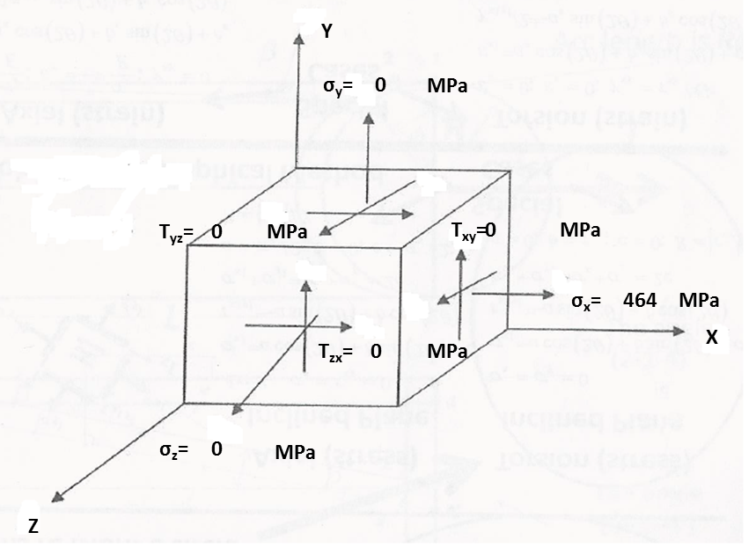

Figure 4 shows the resulting 3D stress element in the shank of the bolt

The resulting Moore’s circle from the 3-D stress element is given in the figure below:

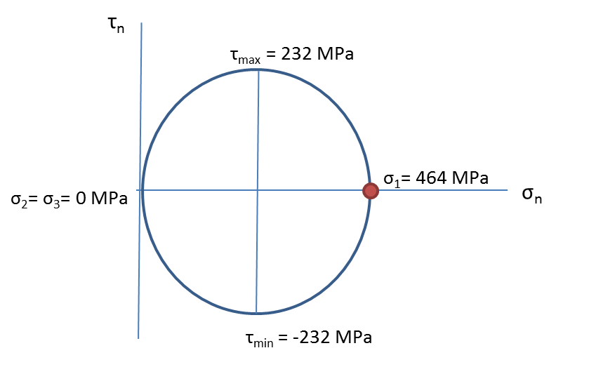

Figure 5 shows Mohr’s circle for the worst case stress along the shank

Because there are only axial tension loads acting in the x direction the generalized Von Mises equation given by equation 1 reduces to the following:

In the next section we will take the resulting stress strain analysis in this section to help us perform fatigue analysis on our mechanical component.

**2.3 Fatigue Failure Analysis and Life Expectancy**

Consider all mechanical parts. Even if you design them while satisfying mechanical strength criteria, it may fail due to a phenomenon called fatigue. Historically many design disasters have happened by neglecting the effect of the fatigue factor. Fatigue failure results from a fluctuating stress. When such fluctuating stress acts on a material, it will initiate micro cracks **[7]**. The crack will continue to grow with a fluctuating stress. Eventually, it will lead to an abrupt failure without any warning. In the below sections, fatigue modeling of our mechanical component will be evaluated. An example of a head bolt which has failed due to fatigue is given in the following picture:

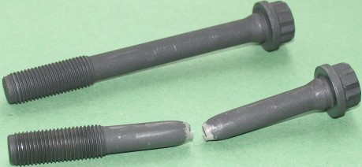

Figure 6 shows a failed head bolt as a result of fatigue [4]

In designing our mechanical component, it would be desirable to obtain actual fatigue data related to the geometry, loads, and conditions that the mechanical component would encounter performing its function. Unfortunately, this would require too much time and money for a college student. Fortunately, there are empirical factors associated to steel that can be applied to our given component to generate an acceptable S-N Curve. These empirical factors are the temperature factor CT, reliability factor CR, surface factor CS, gradient factor CG, and load factor CL. Given that our component is only exposed to axial loads, an S-N curve will be generated with the following empirically developed equations for the axial condition:

(103 cycle strength) (7)

(106 cycle strength) (8)

The values of the fatigue factors used for estimating the fatigue strength of the mechanical component under the given conditions is summarized in the table below. Equations used to calculate a few of the fatigue factors is given below the table. The remaining values where acquired from table 8.1 in Fundamentals of Machine Component Design textbook.

|  |  |  |
| --- | --- | --- |
| **TABLE 3: Fatigue Factors applicable to the design, loading conditions, and environment of the mechanical component** | | |
| **Fatigue Factor** | **Value** | **Criteria** |
| CS | 0.77 | Machined |
| CG | 0.99 | 0.11< d<2 in |
| CT | 0.81 | T<840 F |
| CR | 0.75 | 99.9% |
| CL | 1.00 | Axial Loaded |

(9) **[2]**

(10) **[2]**

Instead of using **equation 9** to calculate the size factor Cs one can get the value from a chart as shown below:

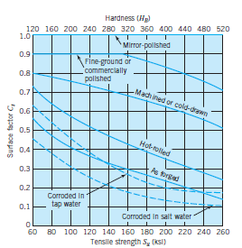

Figure 7 shows the graphical method used to acquire surface factor, Cs [5]

If one knows the tensile strength of the material and the surface finish, the size factor can be determined.

Using the empirical relationships which include fatigue factors, an S-N curve can be developed based on the conditions that our mechanical component experiences. Shown below is a graph that compares the S-N curve of the mechanical component from an R.R. Moore rotating beam fatigue test and an S-N curve empirically derived that includes the effect of fatigue factor values shown in **Table 3**:

Figure 8 compares S-N curves between a standard Moore Tensile Test and the empirically derived S-N curve that includes fatigue factors

A comparison between the two models reveals major differences. For instance, the endurance limit (knee) from the empirically derived S-N curve is 54% less than the value from the Moore test. In addition, the component is predicted to fail at a much lower peak alternating stress than the R.R Moore test predicts. The value added when fatigue factors are taken into consideration is more accurate S-N curves that model fatigue.

In order to evaluate failure due to fatigue, a loading condition of the mechanical component must be established based off of Free Body Diagrams. The current loading condition being evaluated is when the combustion chamber pressure is 4000 kPa. Under this condition, the bolt experiences a mean stress of 420 MPa and an alternating stress of 44 MPa as shown in **Figure 2**.

Several fatigue models have been developed to predict the fatigue life of bolts when they are fastened. The Fatigue models fall into two categories, i.e. notched and un-notched fatigue models. The fatigue models that pertain to notched specimens in our analysis include the Gunn, Modified Goodman, and the Modified Gerber. The fatigue models that pertain to un-notched specimens in our analysis include the Goodman, Gerber, and Soderberg. Un-notched specimens are those that are smooth, have uniform sections, and have no irregularities. In practice, nearly all engineering components have imperfections, i.e. minimal changes in section or shape. Holes in a material, filleted bars, and threads are just a few examples of imperfections that change the stress distribution in a material. These are known as notched specimens and basic stress analysis equations no longer apply because the discontinuities change the stress distribution resulting in local increase in stresses, i.e. stress concentrations **[8]**. The dimensionless geometric stress concentration factor Kt is used to correct for the change in stress distribution of a material and is associated with the specific geometry of a mechanical component and loading condition of the part.

If the material has no imperfections, the geometric stress concentration factor is equal to one. If the material is irregular, the geometric stress factor is greater than one **[8]**. The geometric stress concentration factor Kt is used to develop the Gunn fatigue model and in our case it was determined by the following graph for axial loading:

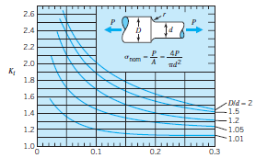

Figure 9 shows the stress concentration factor graphs for axial loading [5]

For our head bolt, the fillet size, r, is on the order of .3 and the D/d ratio is approximately one. Thus the stress concentration factor we will use in the forgoing analysis will be equal to 1.1.

Another factor that is used to account for irregularities and discontinuities is the fatigue stress concentration factor; Kf.Kf is the ratio of the un-notched to notched endurance limit and is related to the geometric stress concentration factor through the following equation **[2]**:

(11)

Kf is used to develop the Modified Gerber and Modified Goodman fatigue models. The notch sensitivity factor (q) is determined from charts. An example chart is given below:

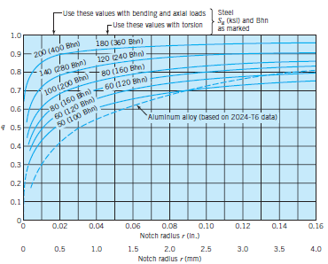

Figure 10 shows notch sensitivity curves for aluminum alloys of different hardness’s [2]

The notch sensitivity factor is dependent on the geometry and hardness of the material.

The figure below shows the un-notched and notched fatigue models with the current operating point. The parameters used in the fatigue modeling are shown in **Table 4**:

Figure 11 shows a variety of different empirical fatigue lines and the operating point

|  |  |  |
| --- | --- | --- |
| **TABLE 4: FATIGUE MODELING PARAMETERS AND OPERATING POINT** | | |
| σAlt | 44.4 | MPa |
| σm | 46.4 | MPa |
| Su | 800 | MPa |
| Sy | 640 | MPa |
| Sn'(106 cycles) | 260 | MPa |
| q | 0.71 |  |
| kt | 1.1 |  |
| Kf | 1.07 |  |

The notch sensitivity factor (q) and the fatigue stress concentration factor were determined from charts. The geometric stress concentration factor (Kf) was calculated from **equation 11**. The design criteria for the bolt, i.e. the number of oscillations the component is expected to last was chosen to be at 10E6 cycles (L6) which corresponded to the knee on the S-N curve shown in **Figure 8**. By evaluating the fatigue models at the endurance limit (knee value) we can ultimately determine if our mechanical component has infinite life.

The relevant fatigue model in our analysis is the Gunn Model. R .L Burguete and E A Patterson performed a study on the effect of mean stress on the fatigue limit of high tensile bolts. The Figure below presents there results:

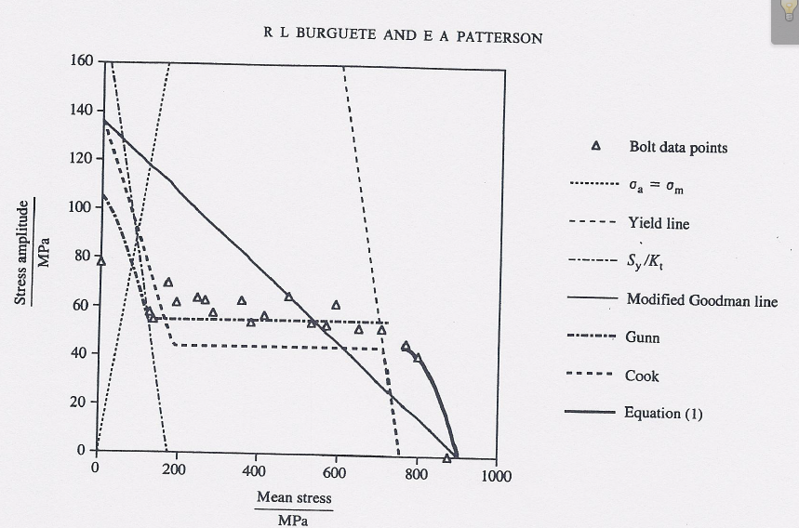

Figure 12 Fatigue plot showing the correlation between the fatigue strength of the bolts and the different fatigue models [3]

From the above figure, the best correlation between the bolt data points and empirical lines is the Gunn Model. Thus in the forgoing analysis we will proceed with the Gunn Model. The Figure below compares the operating point to the Gunn Model using the same parameters as indicated in **Table 4:**

Figure 13 shows the Gunn fatigue model plotted against the operating point

The operating point falls below the failure criteria defined by the Gunn model. This suggests that at the current loading condition, the mechanical component will never experience failure. We will further investigate the safety of the mechanical component by determining a safety factor.

The mechanical component must be designed to withstand an overload to account for uncertainties that might exceed normal loading conditions. Once the design conditions are fixed, a safety factor must be determined. The selection of safety factors is largely dependent on engineering judgment based on a number of factors shown below:

1) The reliability of strength and design data used for design

2) The degree of similarity of service conditions and test conditions used for determining the design data

3) The reliability and accuracy of loading assumptions used for design.

4) The consequences of failure: e.g. hazards presented to human beings and economic implications. **[1]**

Our mechanical component has been engineered by a respectable manufacture and has proven to be reliable based off of the company’s success in the motorcycle industry. Thus a safety factor of 1.25 to 1.5 or greater will be assumed as a reliable safety factor for the given mechanical component **[2]**. The method to acquire the safety factor for the Gunn Model can be visualized by the figure below:

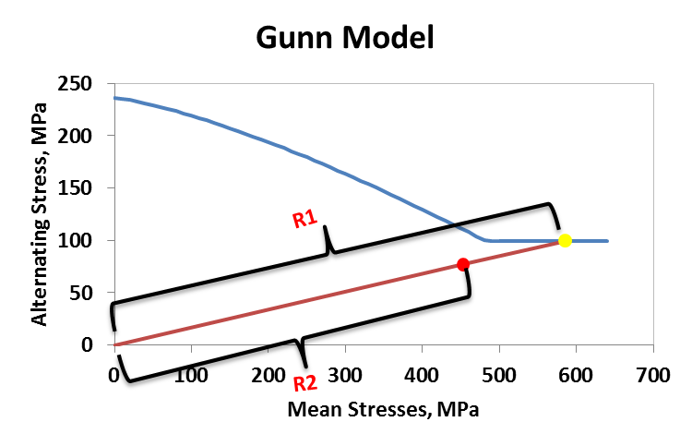

Figure 14 shows the definition of the safety factor applied to the Gunn Model

The generalized safety factor applied for our loading condition is given by the following equation which was derived based off of the geometry in **Figure 14**:

(12)

The calculated safety factor was 2.26 for the current loading condition which is much greater than an industry applied value of 1.25, thus the design of this bolt under the given loading conditions is adequate. Below shows the safety factors for the other fatigue models based off of the parameters in **Table 4:**

Figure 15 shows the safety at the current operating point

The red bars represent the safety factors associated with a notched specimen and the blue bars represent the safety factors for the un-notched specimens. The safety factors vary above and below the Gunn model. This could have a dramatic effect on the economics of designing the mechanical component. For instance, if the Soderberg model was the fatigue model applied to this mechanical component, then the engineer would have to strengthen the bolt by using an improved design or paying for a more expensive material to satisfy a safety factor of 1.25.

**2.4 Simulation**

The previous calculations were based off of fundamental equations simple enough to do by hand or in a spreadsheet. In this section we apply simulation software i.e. SolidWorks, which applies finite element analysis to assign stresses to grid blocks. In the analysis of the given loading condition on the mechanical component, the head of the bolt was fixed and a force equivalent to the piston force and preload force was applied at the end of the shank. A fine mesh was created and applied to the simulation because it creates smaller grid blocks within the mechanical component thus giving more accurate results.

The max and min stress values and locations shown in the figure below:

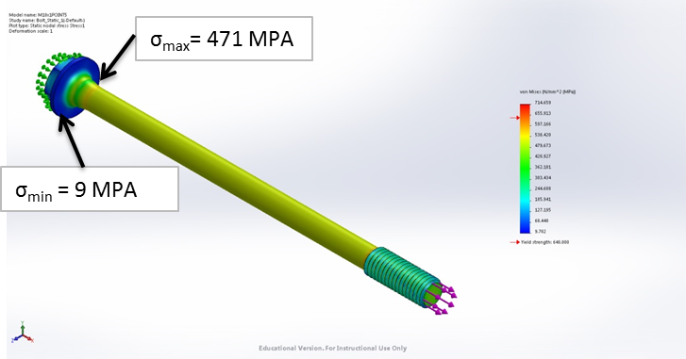

Figure 16 shows the stress distribution on the bolt and the locations of the max and min stresses

The max value of stress is 471 MPa and is located in the shank just below the bolt head. The minimum value of stress is 9MPa and is located on the bolt head where the cross sectional area is the largest. The figure below shows the strain distribution along the bolt (i.e. elongation):

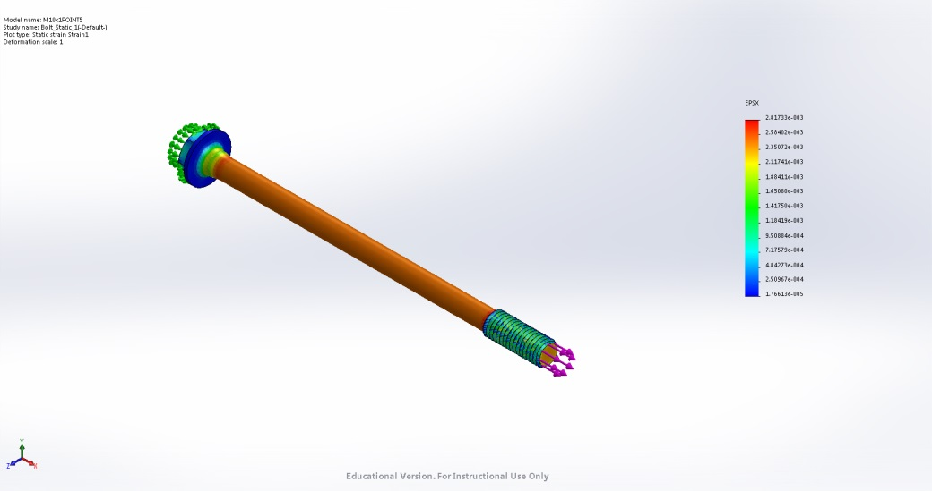

Figure 17 shows the strain distribution along the bolt

The above picture shows that the shank experiences the greatest value of strain (orange) whereas the bolt head experience very little to no strain (blue). This makes sense because under the axial load condition, the bolt head has the largest cross sectional area thus it will experience the least amount of stress and strain. The shank has the lowest value of cross sectional area thus it should experience the greatest amount of stress and strain.

**2.6 Individual Summary and Conclusions**

From the Free body diagrams and stress equations we were able to determine the maximum and minimum stresses placed on the component. The maximum stress resulted from the superposition of two stress loads and was determined to be 464 MPa. The minimum stress condition resulted from the preload stress and was calculated to be 346 MPa. Under the current loading conditions the resulting alternating stress and mean stresses will not cause the component to fail due to fatigue based off of the Gunn fatigue model. Thus the bolt is expected to have infinite life under the current loading conditions. The relevant fatigue model to our mechanical component is the Gunn model. The Gunn model best fits our application because of the study conducted by R.L Burguete and E.A. Patterson. In their study, they verified that the fatigue limit of high tensile bolts correlated the best with the Gunn model, thus we applied it to our loading condition. The safety factor of the bolt was calculated to be 2.26 which exceeded an industry accepted value of 1.25. The simulation software came to similar conclusions as we did using the fundamental equation. Both methods predicted that the worst case stress under the given loading conditions would occur in the shank. This makes sense for the axial load condition because the shank contains the smallest cross sectional area on the bolt.

In this project I learned not only about the technical details behind the fatigue phenomenon but also the value of reading papers relevant to the topic of study. It is interesting that a study conducted in 1995 revealed that the Gunn model most accurately predicted the fatigue limit of bolts under high tensile stresses. Yet, you cannot find the Gunn model used in any textbook, even the newer ones. The value of literature means more to me now than it did previously. I also got valuable experience working on a team. The team environment is something we will all face after we graduate and gaining some experience now could only help us in the future. I look forward to the remaining team projects and hope to continue to improve my skills in a team environment.

We made the mistake in initially evaluating a brake rotor bolt. Under the loading conditions it could experience, the resulting alternating loads and mean stresses were too small to be interesting. We had to select a new component to analyze two weeks into the project. As a result we had to devote a lot of time in a little amount of time to meet the presentation and project deadlines. In the future we will be wiser in selecting our mechanical component to analyze that way we don’t waste two to three weeks of time and can deliver a better and more polished presentation and individual and team reports. Also we plan to meet with Stalford more frequently to help us solve problems that we may encounter in our project.

**2.7 List of References**

[1] Osisanya, S.O. 2013, *Drilling and Completions*, Mewbourne School of Geological Engineering, Norman.

[2] Budynas, R.G. and Nisbett, K.J. 2011, *Shigley’s Mechanical Engineering Design 9th edition*, McGraw Hill, New York.

[3]Burguete, R.L. and Patterson, E.A. “The effect of mean stress on the fatigue limit of high tensile bolts”, Proc. Inst. Mech Burguete, R.L. and Patterson, E.A. “The effect of mean stress on the fatigue limit of high tensile bolts”, Proc.. Engrs., 1995, vol. 209, 257-262.

[4]Bolt Science, 2013, *Strength of threaded Fasteners,* Bolt Science Limited, 29 January 2015,

http://www.boltscience.com/pages/strength.htm

[5[Juvinall R.C. and Marshek M.M. 2012. *Fundamentals of Machine Component Design*. John Wiley & Sons Inc. Danvers.

[6] Maryland Metrics, 2012, *Maryland Metrics Thread Data Charts,* Maryland Metrics, 27 January 2015, http://mdmetric.com/tech/M-thead%20600.htm.

[7] Learn Engineering, 2013. Fatigue failure analysis, LearnEngineering.org & Imajey Consulting Engineers., 27 January 2015, <http://www.learnengineering.org/2013/03/fatigue-failure-analyis.html>

[8] Corrosionpedia, 2015. *Stress Concentration Factor (Kt).* 29 January 2015, <http://www.corrosionpedia.com/definition/1035/stress-concentration-factor-kt>